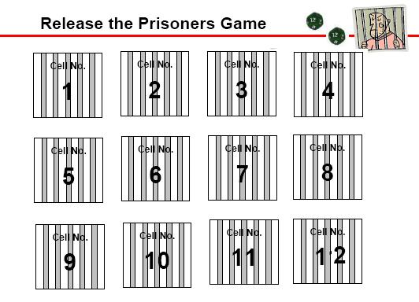
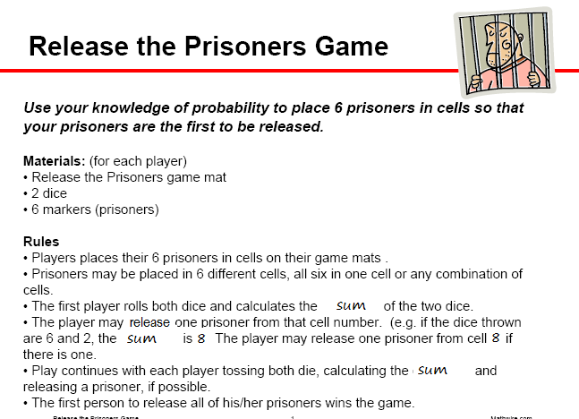
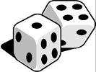EXPERIMENTAL PROBABILITY
SUM | Frequency Tally
2
3
4
5
6
7
8
9
10
11
12
THEORECTICAL PROBABILITY
SUM | Possible Combinations | Total Combinations to Achieve SUM
2 | 1 + 1 | 1
3 | 1 + 2, 2 + 1 | 2
4 | 1 + 3, 2 + 2, 3 + 1
5
6
7
8
9
10
11
12

